Images of our May 2022 Visit at Bear Spring Camps, Belgrade Lakes, Maine

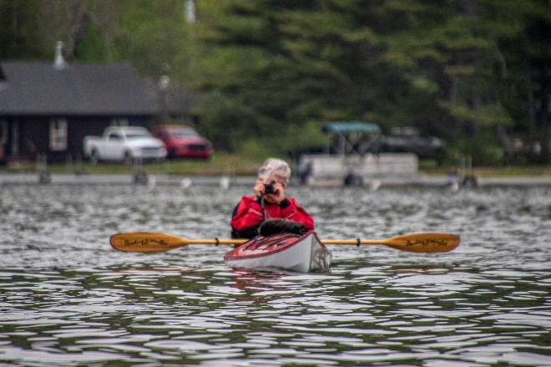Another Spring rolled around, the Bear Spring Camps opened again in May, and there we were.  
We thoroughly enjoyed ourserlves between light kayaking and reading various fiction/non-fiction prose even with one of the colder and windier Spring weeks we have experienced there. The dining room, housekeeping, and grounds staff were up to their usual top-notch service. The bass continued to respond quite nicely to my ancient top-water lures and the great Meadow Stream was peaceful and extremably navagiable. While the double digit winds were steady from the north and south, such challenges also can be a blast!

This photo album includes various photos of us kayaking, and doing this and that while absorbing the wildlife and tranquility. The brisk southerly windstorms offered neat drifting northerly and a demonstration on the last day of who is in charge , but, hey, as kayakers we smiled!

We had an excellent week and we are looking forward to returning in the Fall.

And for the photos, click [Bear Spring Camps, ME, - May 2022.](https://photos.app.goo.gl/MweaFUhWfDPvtZNN7) You are encouraged to “zoom in”.